**Address Validation Setup Document for Microsoft Dynamics 365 Business Central**

Contents

**1.Introduction** 3

**2.Address Validation Setup** 4

# **1.Introduction**

**Validate (primarily US-American) your ship-to information in open document of SALES/PURCHASE/SERVICE documents**

Address Validation tool validates postal addresses from the UPS address book and gives the suggestions of ship-to information based upon below parameter.

* Address
* City,
* Zip (postal code),
* State

**Add-in capabilities**

When this add-in is used, it

* Can read the entered Ship-to address from the sales order page and suggest you the matching address which you can opt to update on the document.
* Can verify the address with the real time UPS address book and avoid entering wrong shipping address
* You can enable this functionality for Sales, Purchase and Service transaction and enable this add-in to suggest you the matching address.

# **2.Address Validation Setup**

User can easily enable or disable the Address Validation functionality from the Address Validation setup page.

Once user disable the address validation, no address validations action will not work from any of the pages.

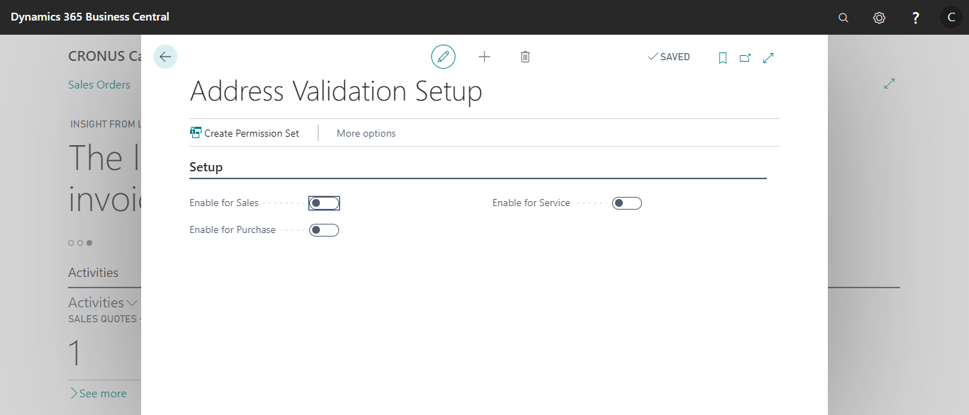

1. **Enable for Sales:** Enables the users to use the Address validation app for Sales documents
2. **Enable for Purchase:** Enables the users to use the Address validation app for Purchase documents
3. **Enable for Service:** Enables the users to use the Address validation app for Service documents